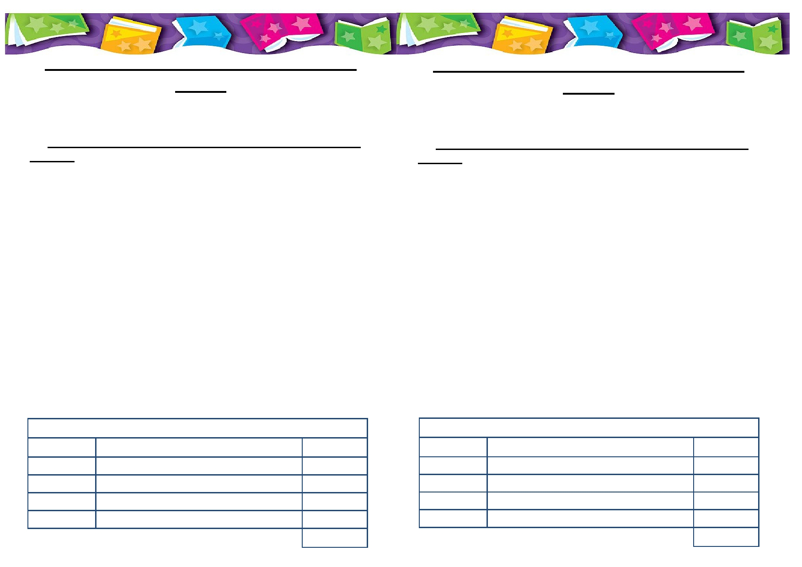
The Travelling Book Fair is coming to
Grove!
Following the success of our last book fair, we are delighted to
announce another fair, running for two days, this June!
On Tuesday 11th June and Friday 14th June from 3.45pm to
4.45pm you will be able to visit the fair and choose from a wide
selection of books all on a three for two offer.
Your support with these events helps to raise money towards
books for our classrooms for your children to share and enjoy.

If you cannot make it to the fair, but still wish to make a
purchase from the attached leaflet, please complete the slip at
the bottom of this page and send payment into your child's teacher in a named, sealed envelope.

We look forward to seeing you there!

We look forward to seeing you there!
The Travelling Book Fair is coming to
Grove!
Following the success of our last book fair, we are delighted to
announce another fair, running for two days, this June!
On Tuesday 11th June and Friday 14th June from 3.45pm to
4.45pm you will be able to visit the fair and choose from a wide
selection of books all on a three for two offer.
Your support with these events helps to raise money towards
books for our classrooms for your children to share and enjoy.

If you cannot make it to the fair, but still wish to make a
purchase from the attached leaflet, please complete the slip at
the bottom of this page and send payment into your child's teacher in a named, sealed envelope.

We look forward to seeing you there!

Childs Name: ______________________ Class _______________ Childs Name: ______________________ Class _______________

Book Code Title Price Book Code Title Price

Total Cost Total Cost

