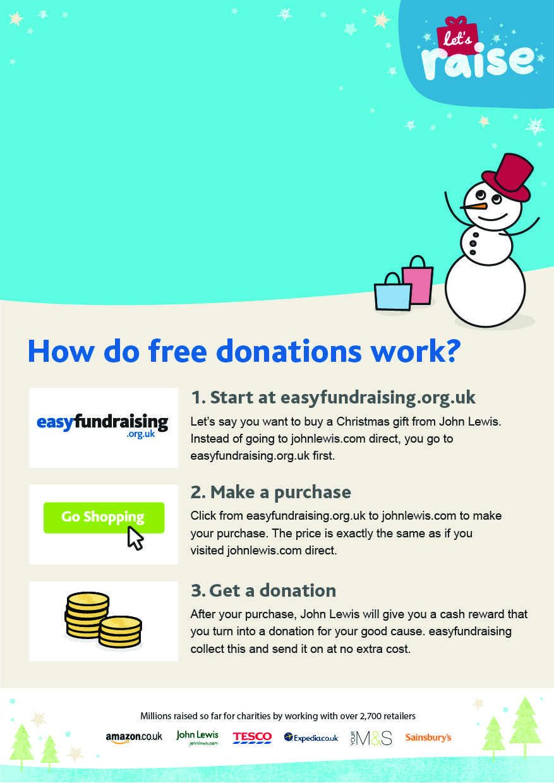­

Please support us at:

**https://www.easyfundraising.org.uk/causes/groveacademy/**

Please support us at: **https://www.easyfundraising.org.uk/causes/groveacademy/**

Help Grove Academy raise free funds when you shop online!

Help Grove Academy raise free funds when you shop online!