Our provision will be continually assessed due to:
- Local and national Government directives
- Numbers of children that we need to provide childcare for
- The health of our team
As many of you are aware we have been offering daily provision (including wrap around care) for ‘critical’ key worker children throughout the lockdown period. This provision will continue. Therefore, this handbook will share with you arrangements for both ‘critical’ key worker children and children who are accessing the school following the phased reopening.

Entrance to school | - Your child will be allocated an entrance, which will be either:  - Turner Street small blue gate (by the Y5 classroom mobiles)  - Myatt Street small black gate (back of the school)  - When dropping off and collecting your child we are asking parents to follow a one-way system so that social distancing measures can be put into place. The map below shows the school and the one-way systems. Times will be staggered as detailed below. There are spots marked on the pavement, please wait on one of these.  - Times will be allocated, they will be either 9:05am or 9:20am for arrival and 3.00pm or 3:15pm for collection. (excluding BASC children).  - Strictly one parent/carer only MUST accompany their child to and from school, no siblings unless absolutely necessary (if siblings accompany they must remain alongside the adult). NO PUPIL, REGARDLESS OF AGE SHOULD WALK TO OR FROM SCHOOL ON THEIR OWN.  - 1 member of SLT must supervise each entrance during phase 1 until satisfied that all control measures are being applied consistently  - Parents / carers to socially distance whilst they wait on the pavement outside school – spots on the pavement show where to stand  - Follow the arrows on the pavement which show the one-way system  - A member of SLT will indicate when your child can enter through the gate  - Staff from each bubble will guide pupils to stand on a waiting spot on the playground, when all pupils for that group have arrived (or after 5 minutes if not all arrived), then the pupils will be lead in to their classroom  - Pupils will enter school and sit on designated seats  - If children arrive late they WILL NOT be admitted.  - All bookings to be completed via Survey Monkey before the specified deadline.
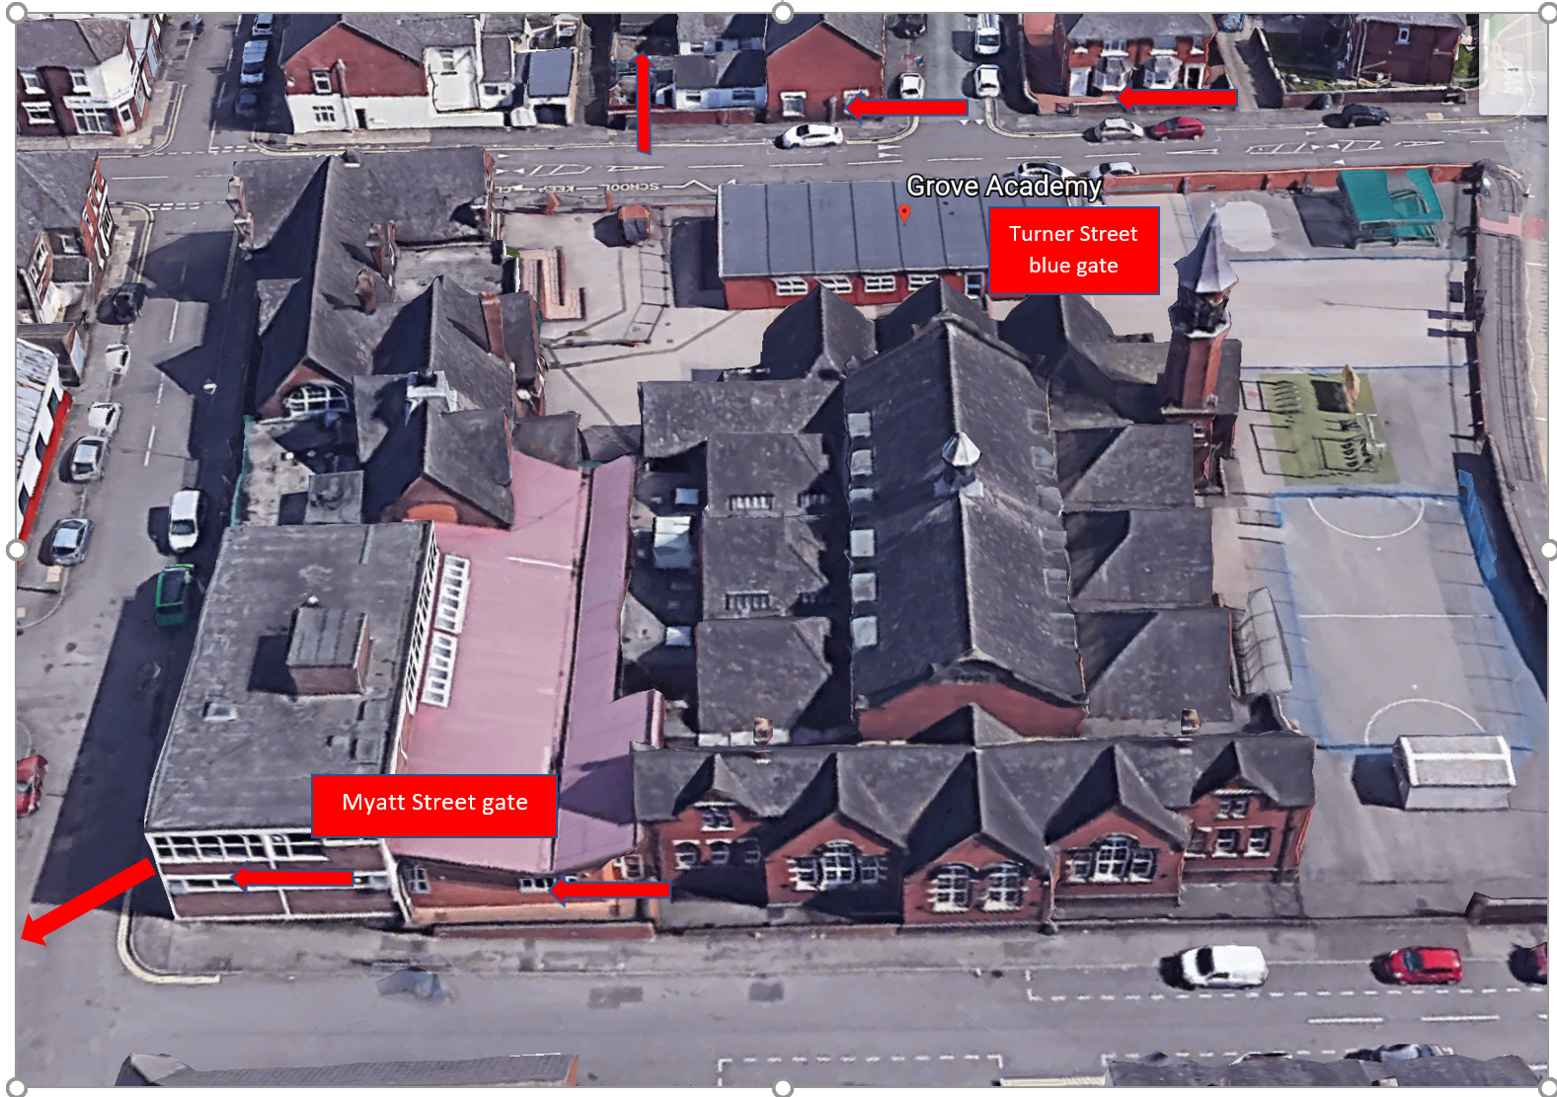
TIMETABLE & ARRANGEMENTS

Groupings | - Pupils will be in a small bubble and stay in that bubble group for the whole day, not mixing with any other bubble  - Each bubble group will have 2 members of staff who will stay with the children in that bubble at all times.  - Children will access outdoor provision as much as possible.
BASC | - Before and After school provision (BASC) can be pre-booked at a cost for ‘critical’ key worker children ONLY from the hours of 8am until 5pm. These will be offered on a first come first serve basis as numbers are capped at 14 children.  - Places must be requested and paid via ParentPay one week in advance. If this can be accommodated, there will be a charge - £3 for the morning session, £6 for the afternoon session.

 | Location in school | pupils | Number of pupils | Staff (T and TSA) first aid | Toilets to be used by pupils | entrance | SLT to supervise gate entry | Time of entry |  | Time of exit
Bubble AB | AB classroom (G35) | Y3 - 6 | Max 9 | Mr. Bateman-Price  Miss Griffiths | Red staff toilets | Myatt Street | SC | 9.05 |  | 3.00
Bubble CB | CB classroom (G31a) | Y3 - 6 | Max 9 | Miss Fryer and Miss Hudson | Red staff toilets | Myatt Street | SC | 9.20 |  | 3.15
Bubble HW | HW classroom (G109) | Y3 – 6 inc. BASC | Max 7 | Miss Williams and Miss Peacock.  BASC Staff  Mrs Saunders and Mrs Edge. | HW toilets | Turner Street blue gate | JBl | 8.00 | 9.05 | 3 | 5
Bubble KE | KE classroom (G110) | Y3 – 6  inc. BASC | Max 7 | Miss Pate and Mr. Hannon | KE toilets. | Turner Street blue gate |  | 8.00 | 9.05 | 3 | 5

WHAT YOU NEED TO KNOW
Clothing | - Pupils to wear comfortable clothes and trainers  - Clothes to be clean on every day
General | - Pupils to bring a water bottle every day, CLEARLY LABELLED with their name.  - If needed, suncream to be applied BEFORE attending school, then to be reapplied by child as needed during the day.  - If your child uses an inhaler, this must be brought to school every day with them, and kept in their bag.
Lunch | - All children to bring a packed lunch with an ice pack from home which will be stored in the child’s designated place (under the desk)  - Lunches and snacks to be eaten in classrooms – no tuck will be provided or on offer from the academy
Hygiene | - All visits to the toilets supervised by an adult  - Regular handwashing modelled and observed by staff  - Enhanced cleaning of resources and environment, deep clean on a Friday  - PPE equipment will be used by staff when necessary  - If a child falls ill, they will be placed in isolation (and supervised from a safe distance). As a result of a child displaying symptoms their household should self-isolate for 14 days and the child for 7 days.
Communication | - Parents and carers to communicate via email or phone calls, the academy office is not open  - Parents to sign an agreement to confirm their adherence to school requirements  - If a child becomes ill at school, they must be collected immediately and school will agree next steps
Revised School Rules | - I will stay 2 metres away from others including my teachers  - I will regularly wash my hands throughout the day for 20 seconds  - I will tell an adult if I feel unwell  - I will not bring items into school from home, or take items home from school  - I will only use the equipment in my pack  - I will not mix with children in a different bubble in school  - I will ask an adult when I need to use the toilet, so they can keep me safe  - I will use the catch it- kill it rules (coughing and sneezing into my elbow or tissue)  - I will follow these rules at all times so that I do not get sent home and are unable to come back to school  The Children will be taught the following to support the revised rules:  - What 2 metres looks like and how to keep this distance between others  - How to thoroughly wash their hands  - What feeling unwell means  - The reasons and importance for not bringing into school items from home or taking items home from school  - The reason and importance of why they can only use their own equipment in their packs  - The reasons and importance of why they are not able to mix with children in different bubbles when in school  - The importance of asking an adult when they wish to use the toilet  - What is meant by the catch it- kill it rule  - Why they will not be allowed back in to school if they do not apply the rules

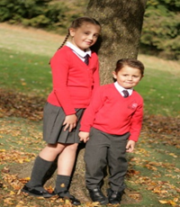  No Uniform | 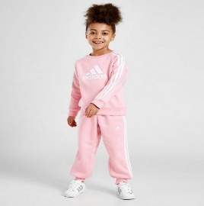  PE Clothes | 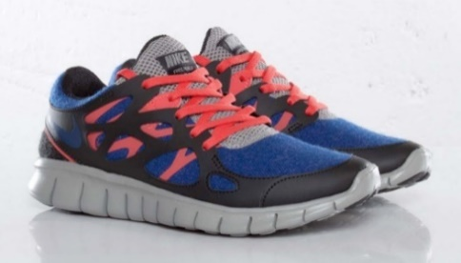  Trainers
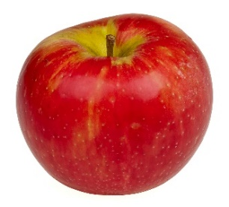  Snacks | 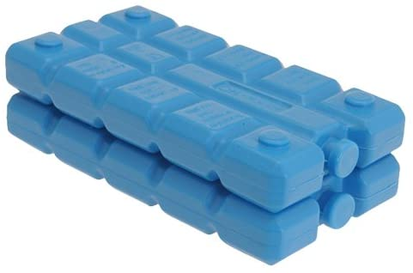  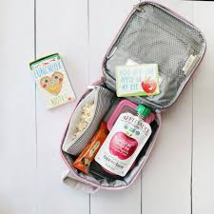  Lunch & Ice Pack | Sun Hats
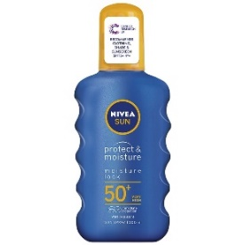  Sun Cream | 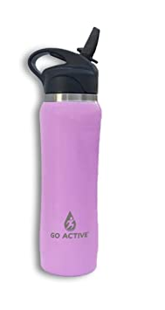  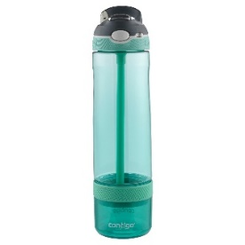  Sports Water Bottle | 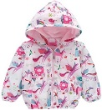  Coat

PARENT AGREEMENT:
I AGREE THAT FOR MY CHILD TO ATTEND GROVE ACADEMY I MUST FOLLOW THE GUIDANCE BELOW:

- Update school immediately if a member of my household becomes ill and follow the self-isolation expectations of 7 days for the infected member of my household and 14 days for all other members of the household.
- Explain clearly to my child what social distancing is and why it is important for it to take place.
- Talk to my child to explain that school may look and feel very different to what they remember and that they may be working with new teachers in new classrooms. You could share the photo below
- Ensure my child arrives promptly and is collected promptly at the times identified above. (Late arrival will not be permitted as gates/doors will be locked)
- If my child is upset and not willing to enter school independently, I will take my child home. I understand that staff cannot comfort my child due to social distancing measures.
- Allow my child’s temperature to be taken on entry using a thermometer.
- Ensure my child wears their PE kit or casual wear which MUST be fresh on each day – we recommend putting clothes straight in the washing machine once returning home from school to minimise and control the spread of infection.
- Ensure my child has a shower or a bath as soon as they return home from school, again to minimise and control the spread of infection.
- Ensure my child wears trainers every day.
- Ensure my child brings a clearly labelled water bottle, sun hat and sun cream OR coat, so they can access outdoors in all weathers.
- Ensure up to date contact details for family members are available within school and emergency contact details should children become poorly/exhibit symptoms of contracting coronavirus.
- Ensure the school is kept up to date with any decisions regarding withdrawing my child from school.
- Treat staff with respect at all times.
- Ensure I observe the one-way system and social distancing markers during arrival and dismissal
- Ensure I do not gather with other parents at the school gate.
- Ensure I do not enter the school premises without a pre-arranged appointment.
- Ensure my child brings their own packed lunch and snacks every day, in a clearly labelled lunch box and include an ICE PACK to keep the lunch cool.
- Ensure I adhere to all of the expectations outlined in this document.
A message from Grove Academy staff
Your children are precious to you and to us. The current situation we are living in has tested and will continue to test us all. As we enter this next phase of opening our school to more children, we know it will continue to be one of the most unchartered times of our personal and professional lives. Remember in the words of Winnie the Pooh ”You are braver than you believe, stronger than you seem, smarter than you think and loved more than you know.” Let the journey continue!
Stay safe and well – your support is immensely appreciated
All staff at Grove Academy xxx

PHOTOGRAPHS TO USE WHEN TALKING TO YOUR CHILD

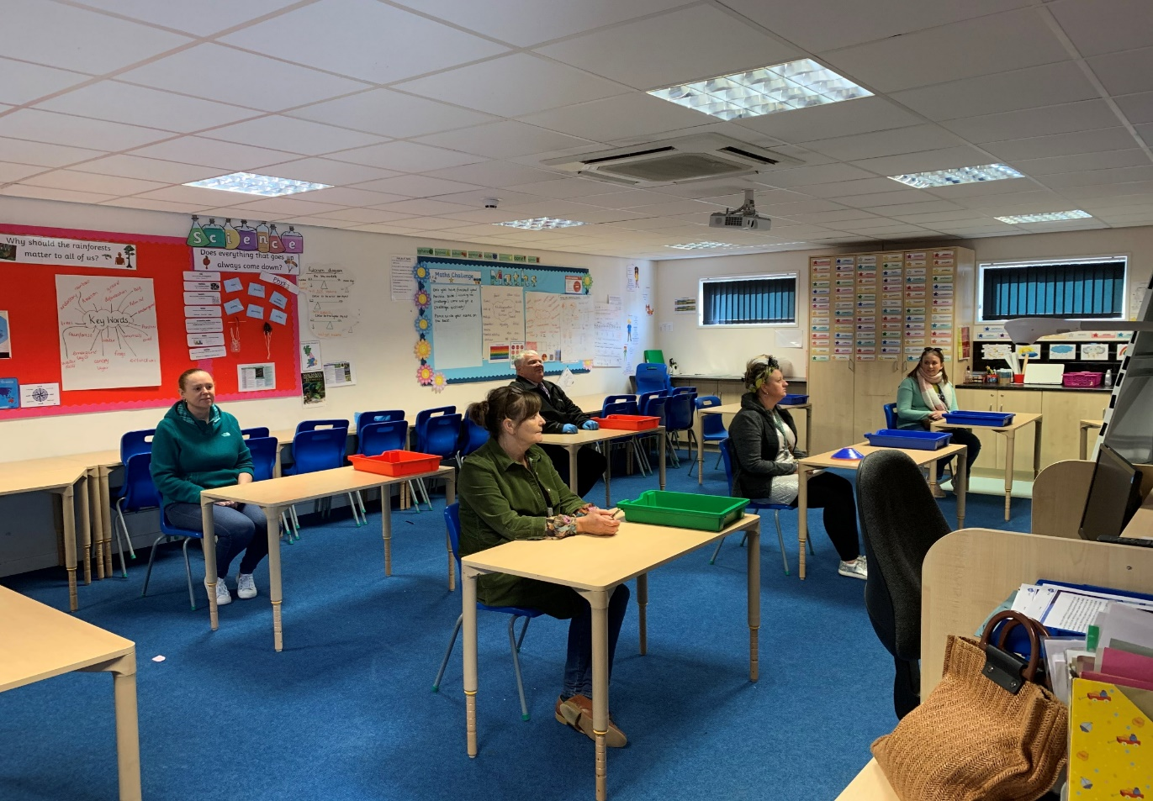
Each classroom has been cleared of any soft furnishings and tables have been set out so each child can sit at their own table with their own ‘tray of resources’. Each child will have their own tray to put their belongings in each morning when they arrive.

All bookcases and cloakrooms have been taped off. Any resources that are not needed have been covered over or removed. This will be very different to the school your child knows and remembers. Therefore, please share this information so they have an understanding of what to expect when they arrive at school.

