Our provision will be continually assessed due to:
- Local and national Government directives
- Numbers of children that we need to provide childcare for
- The health of our team
As many of you are aware we have been offering daily provision (including wrap around care) for ‘critical’ key worker children throughout the lockdown period. This provision will continue. Therefore, this handbook will share with you arrangements for both ‘critical’ key worker children and children who are accessing the school following the phased reopening.

Entrance to school | - Your child will be allocated an entrance, which will be either: (see grid below for full details)  - Turner Street small blue gate (by the Y5 classroom mobiles)  - Myatt Street small black gate (back of the school)  - Keelings Road black gate  - Turner Street main black gate  - When dropping off and collecting your child we are asking parents to follow a one-way system so that social distancing measures can be put into place. The map below shows the school and the one-way systems. Times will be staggered as detailed below. There are spots marked on the pavement, please wait on one of these. Where 2 bubbles use the same entrance at staggered times, please don’t join the queue until the first bubble has entered.  - Times will be allocated as per the grid below, and will be confirmed via text message prior to your child’s first session in school.(excluding BASC children).  - Children must access their place Monday-Thursday each week unless they have been allocated part time place e.g. Y6.  - Strictly one parent/carer only MUST accompany their child to and from school, no siblings unless absolutely necessary (if siblings accompany they must remain alongside the adult). NO PUPIL, REGARDLESS OF AGE SHOULD WALK TO OR FROM SCHOOL ON THEIR OWN.  - 1 member of school staff must supervise each entrance during phased reopening until satisfied that all control measures are being applied consistently  - Parents / carers to socially distance whilst they wait on the pavement outside school – spots on the pavement show where to stand  - Follow the arrows on the pavement which show the one-way system  - A member of staff will indicate when your child can enter through the gate  - Staff from each bubble will guide pupils to stand on a waiting spot on the playground, when all pupils for that group have arrived (or after 5 minutes if not all arrived), then the pupils will be lead in to their classroom  - Pupils will enter school and sit on designated seats  - If children arrive late they WILL NOT be admitted.  - All bookings to be completed via Survey Monkey before the specified deadline.  - BASC to be booked and paid for in advance, or place will be withdrawn. We require 1 week’s notice of any changes to your requirements. If you need to contact the BASC team in an emergency, or wish to collect your child before 5pm, please contact the team directly on 07376 046826.

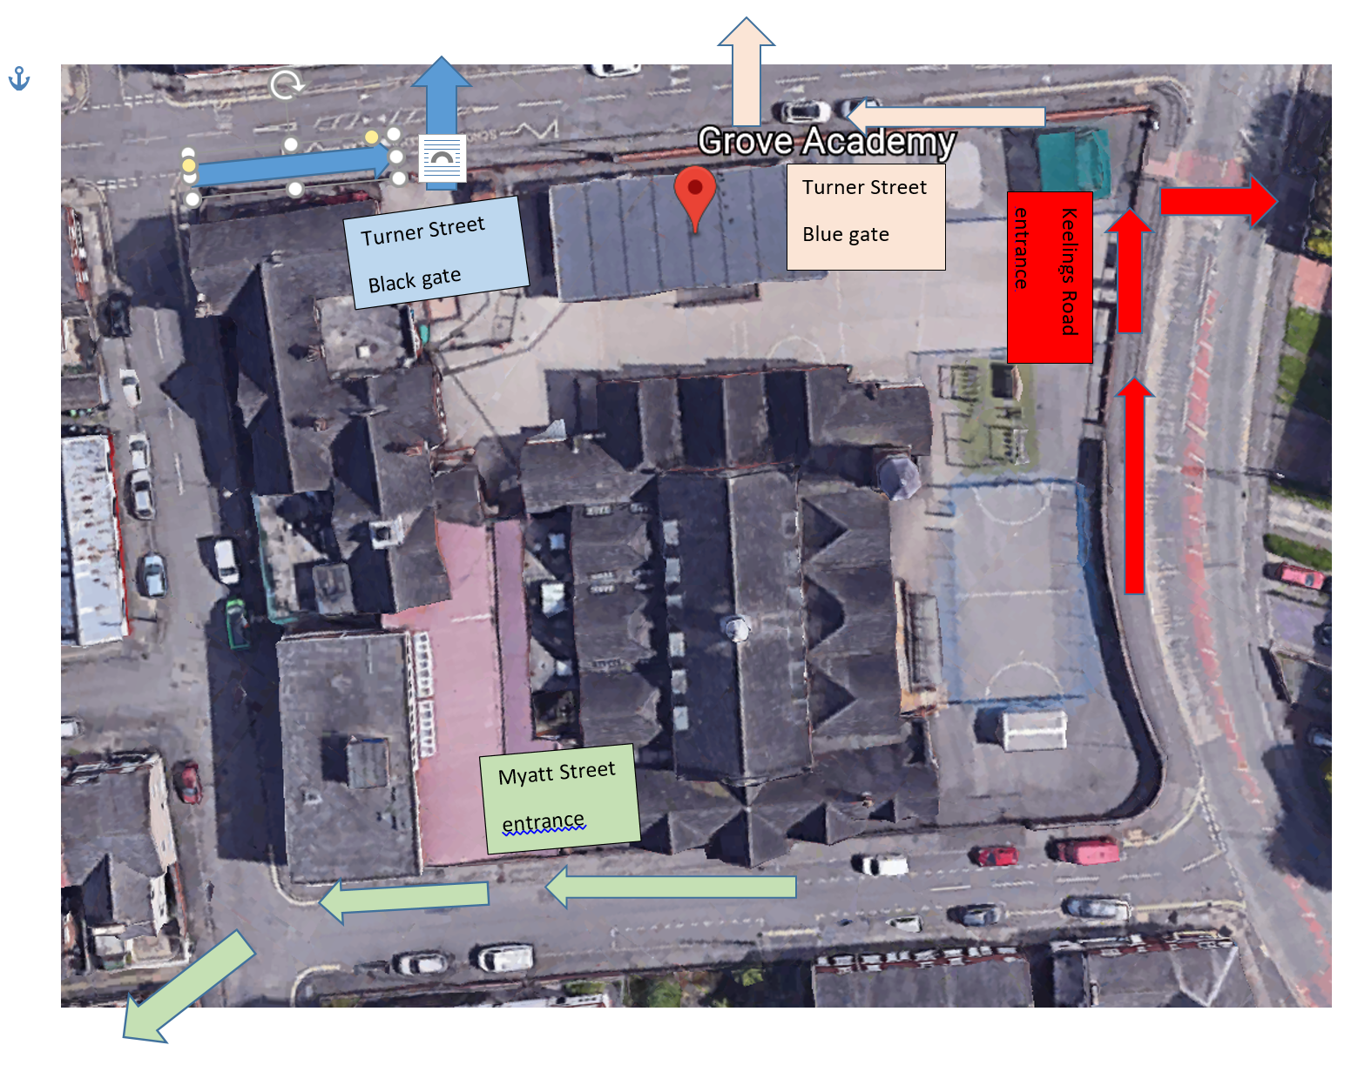
TIMETABLE & ARRANGEMENTS

Groupings | - Pupils will be in a small bubble and stay in that bubble group for the whole day, not mixing with any other bubble  - Each bubble group will have 2 members of staff who will stay with the children in that bubble at all times.  - Children will access outdoor provision as much as possible.  - It may occasionally be necessary to reorganise bubbles, e.g. when moving to BHA, to ensure year group teaching. Parents will be informed and it is their choice whether their child continues to attend. Mitigating measures such as hand-washing and social distancing are expected to limit the risk of infection.
BASC | - Before and After school provision (BASC) can be pre-booked at a cost for ‘critical’ key worker children ONLY from the hours of 8am until 5pm. Early collection can be arranged by calling 07376 046826. These will be offered on a first come first served basis as numbers are capped at 14 children.  - Places must be requested and paid via ParentPay one week in advance. If this can be accommodated, there will be a charge - £3 for the morning session, £6 for the afternoon session.

 | Location in school | pupils |  | Days | Number of pupils | Staff (T and TSA) first aid | Toilets to be used by pupils | entrance |  | SLT to supervise gate entry | Time of entry
Bubble AB1 | AB classroom (G35) | Y6 (not going to BHA) | Monday, Tuesday |  | Max 14  Currently 12 | JS – SJ (NQT) | Red staff toilets | Myatt Street | See rota |  | 9.30 | 2.00
Bubble AB2 | AB classroom (G35) | Y6 (not going to BHA) | Wednesday, Thursday |  | Max 14  Currently 12 | LD - LR | Red staff toilets | Myatt Street | See rota |  | 9.30 | 2.00
Bubble CB | CB classroom (G31a) | Mixed age CKW + vul inc. BASC | M, T, W, Th |  | Max 11  Currently 7 | HW-EG  GS/PE- BASC | Red staff toilets | Myatt Street | See rota |  | 08:00  09:05 | 15:00  17:00
Bubble HC | HC classroom | Y5 CKW + vul | M, T, W, Th |  | Max 9  Currently 8 | KE, SE CM (NQT) | Pupil toilets (girls) | Turner Street, then Y5 entrance | See rota |  | 9.05 | 3.00
Bubble JS | JS classroom | Y4 CKW + vul | M,T,W,Th |  | Max 9  Currently 9 | CC –DH | Pupil toilets (girls) | Turner Street Black gate, then Y5 entrance | See rota |  | 9.15 | 3.15
Bubble AF | AF classroom | Y3 CKW + vul | M,T,W,Th |  | Max 9  Currently 8 | AF – AH  JW SE  JC (1 day) NQT | Pupils toilets (girls) | Keelings road gate, then SC door | See rota |  | 9.15 | 3.15
Bubble KE | KE classroom (G110) | Nurture vulnerables | M,T,  w/b 13th July) |  | Max 7  Currently groups of 5 or 6 (3 groups) | LP- EG  DW / LR BASC  SCo, DL | KE toilets. | Turner Street blue gate | See rota |  | 9  11  1.00 | 10.45  12.45  2.45
Bubble LP | LP classroom | Y4 | Mon - wed |  | Max 15 | LP - CP | Red staff toilets | Turner street black | See rota |  | 8.45 | 2.45
Bubble PR | PR classroom | Y5 | Mon - wed |  | Max 15 | PR - AH | Girls toilets | Turner street black | See rota |  | 8.55 | 2.55
Bubble JK | JK classroom | Y3 | Mon - wed |  | Max 15 | JK - DW | Girls toilets | Keelings road | See rota |  | 9.05 | 3.05
Touch point cleaners | JHi  WH

WHAT YOU NEED TO KNOW
Clothing | - Pupils to wear comfortable clothes and trainers  - Clothes to be clean on every day- we will ask you to take your child home if they do not arrive in clean clothes. If a child does enter school in the same clothes as the previous day, parents will be contacted and asked to come and take children home to wash and change.  - We advise children remove their clothes as soon as they return home, place them in the washing machine and shower or bathe.
General | - Pupils to bring a water bottle every day, CLEARLY LABELLED with their name.  - If needed, suncream to be applied BEFORE attending school, then to be reapplied by child as needed during the day.  - If your child uses an inhaler, this must be brought to school every day with them, and kept in their bag.  - All children, regardless of year group, must be dropped off and collected by a family member over the age of 18 years.
Lunch | - If requested by parents, FSM children will receive their lunch provided by City Catering in disposable containers. There is a limited menu choice each day. If a school lunch is chosen, then the weekly food vouchers will be reduced accordingly.  - Children who are eligible for a Free School Meal and who are in school for 4 days will receive a packed lunch on a Thursday afternoon for lunch on Friday. This packed lunch MUST be kept in the fridge and eaten by Friday lunch time.  - If your child is not eligible for FSM, they need to bring a packed lunch, please provide your child’s HEALTHY lunch in a sealed lunchbag with an ice pack in. This will be stored in the child’s designated place (under the desk)  - Lunches and HEALTHY snacks to be eaten in classrooms – no tuck will be provided or on offer from the academy  - Please ensure your child has sufficient snacks and drinks if they are attending BASC  - Please note, due to the current situation, we are unable to allow sharing of food/ cakes/ sweets for children’s birthdays  - The academy kitchen is deep cleaned each Thursday
Hygiene | - All visits to the toilets supervised by an adult  - Regular handwashing modelled and observed by staff  - Enhanced cleaning of resources and environment, deep clean on a Friday  - PPE equipment will be used by staff when necessary  - If a child falls ill, they will be placed in isolation (and supervised from a safe distance).  - Please send in a small packet of tissues with your child  - Children must not wear facemasks in school- if a child arrives in a reusable facemask, they will be asked to remove this, put it in a plastic bag to take home. If a child arrives in a disposable face mask they will be asked to put this in the bin.
Test and Trace | - As you are aware, the Government are implementing the Test and Trace scheme. If any of our staff are contacted through this service and told to self- isolate, it may be necessary for us to close a bubble at very short notice. This is out of our control, and we will communicate this with parents as soon as we become aware this may happen.
Communication | - Parents and carers to communicate via email or phone calls, the academy office is not open  - By sending your child into school you are agreeing to abide by all expectations within this document to help us provide the safest possible environment  - If a child becomes ill at school, they must be collected immediately. As a result of a child being ill, parents should request a test for their child by calling 119, the results of which MUST be shared with school in order for the remainder of the bubble to access a test if necessary. If you refuse to get your child tested, you will need to keep your child isolated at home for the next 7 days, and the rest of the household for 14 days.
Staff illness | If any staff member starts to show signs of Coronavirus, High Temperature, a new or continuous cough, change in taste or ability to smell they will need to:  - Inform SLT on site immediately  - Access a Covid 19 Test  - Self-Isolate and follow NHS advice regarding household isolation until results are known.  - The SLT member of staff will decide on the following depending on staff availability  - Is there a staff member who can cover the bubble – who has not worked in another bubble for past 14 days?  - If Yes – allocate that staff member to the bubble (Teachers can only be replaced with Senior TSA or other teacher.  - If No – Is the bubble a KEY WORKER bubble?  - If Yes – seek support from MAT or LA for alternative available staff / arrange supply staff cover (MUST not have worked at any other school setting for 14 days)  - If No – Close bubble until staff available (Up to 7 days).  The SLT member must also follow the Local outbreak control plan  ..\..\..\SOT Outbreak overview and process for educational settings (shorter version).pptx  - Informing Stoke on Trent Council’s Covid Response team on 01782 231222 or via email address Tracecovid19@stoke.gov.uk
Revised School Rules | - I will stay 2 metres away from others including my teachers  - I will regularly wash my hands throughout the day for 20 seconds  - I will tell an adult if I feel unwell  - I will not bring items into school from home, or take items home from school  - I will only use the equipment in my pack  - I will not mix with children in a different bubble in school  - I will ask an adult when I need to use the toilet, so they can keep me safe  - I will use the catch it- kill it rules (coughing and sneezing into my elbow or tissue)  - I will follow these rules at all times so that I do not get sent home and are unable to come back to school  The Children will be taught the following to support the revised rules:  - What 2 metres looks like and how to keep this distance between others  - How to thoroughly wash their hands  - What feeling unwell means  - The reasons and importance for not bringing into school items from home or taking items home from school  - The reason and importance of why they can only use their own equipment in their packs  - The reasons and importance of why they are not able to mix with children in different bubbles when in school  - The importance of asking an adult when they wish to use the toilet  - What is meant by the catch it- kill it rule  - Why they will not be allowed back in to school if they do not apply the rules
Safety and Fire Drills | - Each bubble has their own fires exit route to maintain social distancing as far as possible.  - Each bubble will practice their fire exit routes regularly  - We will conduct fire drills to ensure children know what to do in the event of a fire  - Usual safeguarding processes apply- there is a Designated Safeguarding Lead contactable at all times if not on site  - Where children are displaying signs of anxiety or requesting 1-1 conversations, support for this will be from the staff within their own Bubble

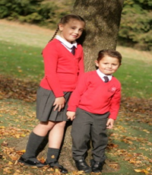  No Uniform | 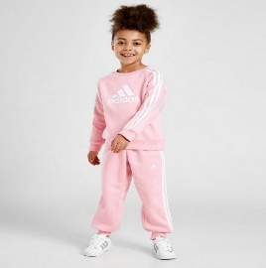  PE Clothes | 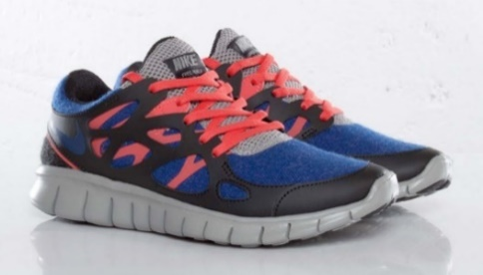  Trainers
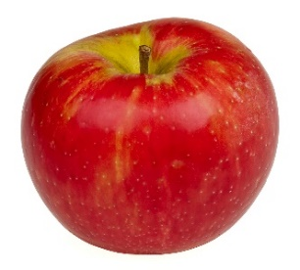  Snacks | 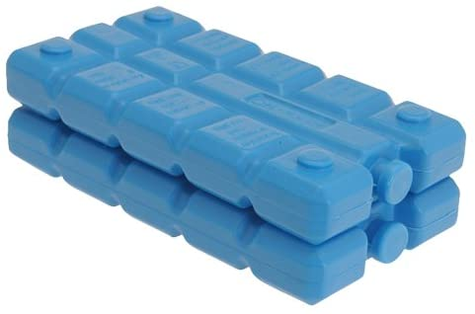  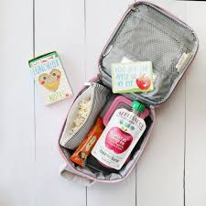  Lunch & Ice Pack | Sun Hats
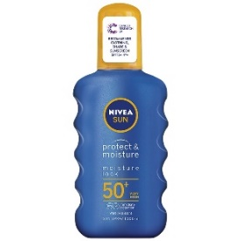  Sun Cream | 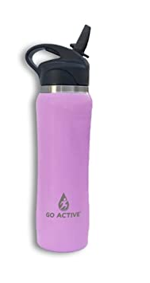  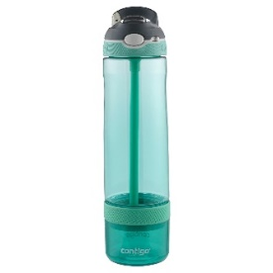  Sports Water Bottle | 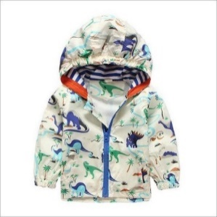  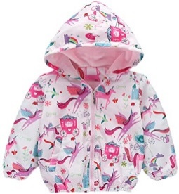  Coat

PARENT AGREEMENT:
I AGREE THAT FOR MY CHILD TO ATTEND GROVE ACADEMY I MUST FOLLOW THE GUIDANCE BELOW:

- Update school immediately if a member of my household becomes ill and will arrange to be tested by calling 119. I will update school with the result as soon as it is available. I understand that if I refuse a test, I will follow the self-isolation expectations of 7 days for the infected member of my household and 14 days for all other members of the household.
- Explain clearly to my child what social distancing is and why it is important for it to take place.
- Talk to my child to explain that school may look and feel very different to what they remember and that they may be working with new teachers in new classrooms.
- Ensure my child arrives promptly and is collected promptly at the times identified above, always accompanied by an adult. (Late arrival will not be permitted as gates/doors will be locked)
- If my child is upset and not willing to enter school independently, I will take my child home. I understand that staff cannot comfort my child due to social distancing measures.
- Allow my child’s temperature to be taken if complaining of feeling ill, with a non- contact thermometer.
- Ensure my child wears their PE kit or casual wear which MUST be fresh on each day – we recommend putting clothes straight in the washing machine once returning home from school to minimise and control the spread of infection.
- Ensure my child has a shower or a bath as soon as they return home from school, again to minimise and control the spread of infection.
- Ensure my child wears trainers every day.
- Ensure my child brings a clearly labelled water bottle, sun hat and sun cream OR coat, so they can access outdoors in all weathers.
- Ensure up to date contact details for family members are available within school and emergency contact details should children become poorly/exhibit symptoms of contracting coronavirus.
- Ensure the school is kept up to date with any decisions regarding withdrawing my child from school.
- Treat staff with respect at all times.
- Ensure I observe the one-way system and social distancing markers during arrival and dismissal
- Ensure I do not gather with other parents at the school gate.
- Ensure I do not enter the school premises without a pre-arranged appointment.
- Ensure my child brings their own packed lunch and snacks every day, in a clearly labelled lunch box and include an ICE PACK to keep the lunch cool.
- Ensure I adhere to all of the expectations outlined in this document.
A message from Grove Academy staff
Your children are precious to you and to us. The current situation we are living in has tested and will continue to test us all. As we enter this next phase of opening our school to more children, we know it will continue to be one of the most unchartered times of our personal and professional lives. Remember in the words of Winnie the Pooh ”You are braver than you believe, stronger than you seem, smarter than you think and loved more than you know.” Let the journey continue!
Stay safe and well – your support is immensely appreciated
All staff at Grove Academy xxx

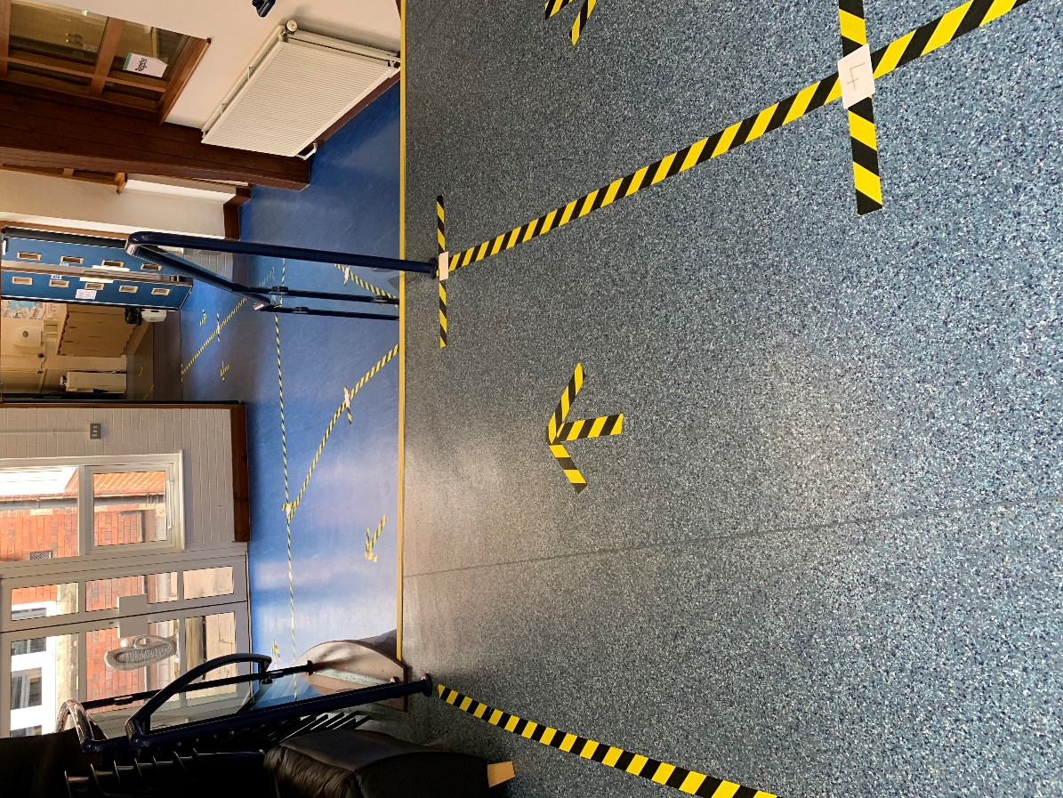
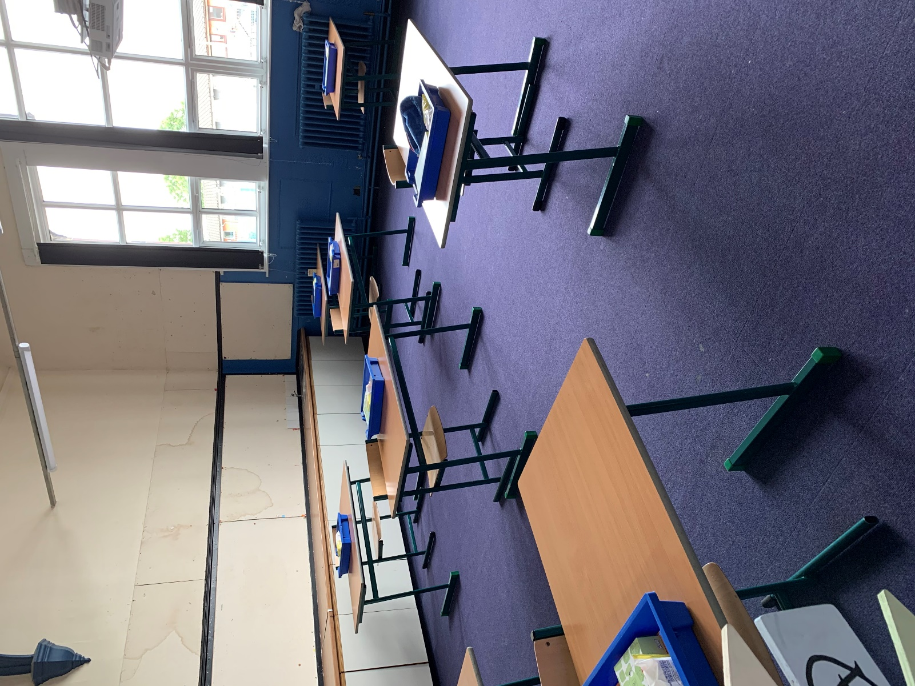
PHOTOGRAPHS TO USE WHEN TALKING TO YOUR CHILD
Each classroom has been cleared of any soft furnishings and tables have been set out so each child can sit at their own table with their own ‘tray of resources’. Each child will have their own tray to put their belongings in each morning when they arrive.

All bookcases and cloakrooms have been taped off. Any resources that are not needed have been covered over or removed. This will be very different to the school your child knows and remembers. Therefore, please share this information so they have an understanding of what to expect when they arrive at school.

