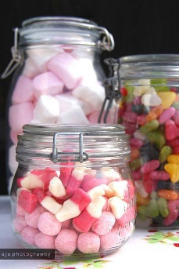
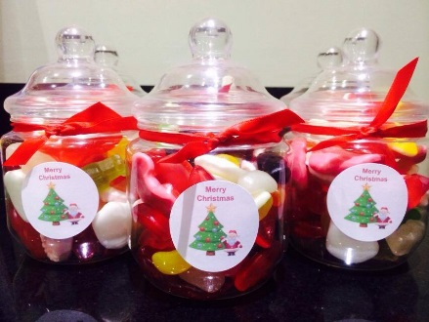
WE NEED YOUR
HELP!
One of our stalls at the Christmas Fayre this year will be a jar stall.
We would like you to donate a jar and fill it with some tasty pre-packaged sweets or something exciting and fun. Maybe some crayons or stationery, or stickers…anything that you think looks exciting or yummy!
You need to decorate it to make it look extra special.
The jars will be sold at the Christmas fayre to raise money for school funds.
To make it even more fun, any jars sent into school will be entered into a Year Group competition and judged.
The best jar wins a voucher to spend on the night!
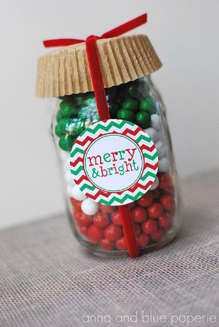
Please can all jars be sent into school by Monday 10th December 2018
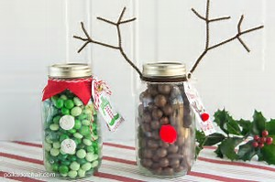
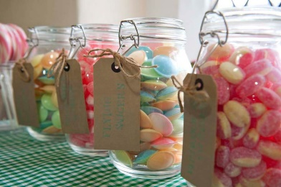
Thank you for all your continued support.

