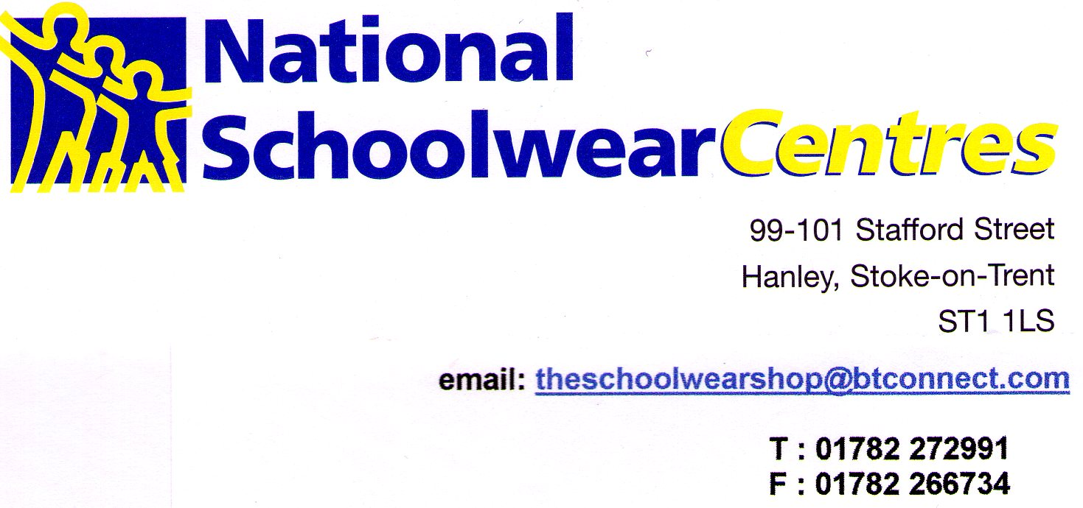

We will be re-opening our shop to customers on 16 June.

When we re-open we will be subject to various procedures to keep our staff and customers safe and to ensure we are COVID-19 compliant.

These measures will include restricting the amount of customers in the shop at any time, social distancing, use of PPE, hand sanitising, allowing only parent/carer with one child into the shop and serving customers on a first come, first served basis. Initially our changing rooms will be closed. We will also be asking parents/carers to ensure their child is kept with them at all times.

Because of the restrictions we will be unable to serve customers as quickly as normal. This will envitability lead to greater queues. We would ask you all to be kind and patient in this very difficult time we find ourselves in.

We would therefore encourage customers to shop earlier than normal to avoid this. In addition we are encouraging customers to use our mail order facility. We do not offer on line mail order. Call us on the number above, use the email address above or message use through facebook, we will call you back, discuss your requirements and mail out your order. The success rate of this is far greater than on-line mail order and usually reduces the amount of items needing to be returned.

Initially our opening hours will be as follows:

Monday – closed
Tuesday – 10.00 am – 4.30 pm
Wednesday -10.00 am – 4.30 pm
Thursday – 10.00 am – 4.30 pm
Friday 10.00 am – 4.30 pm
Saturday 10.00 am – 4.00pm
Sunday – closed

We look forward to seeing you after 16 June. Until then stay safe.

