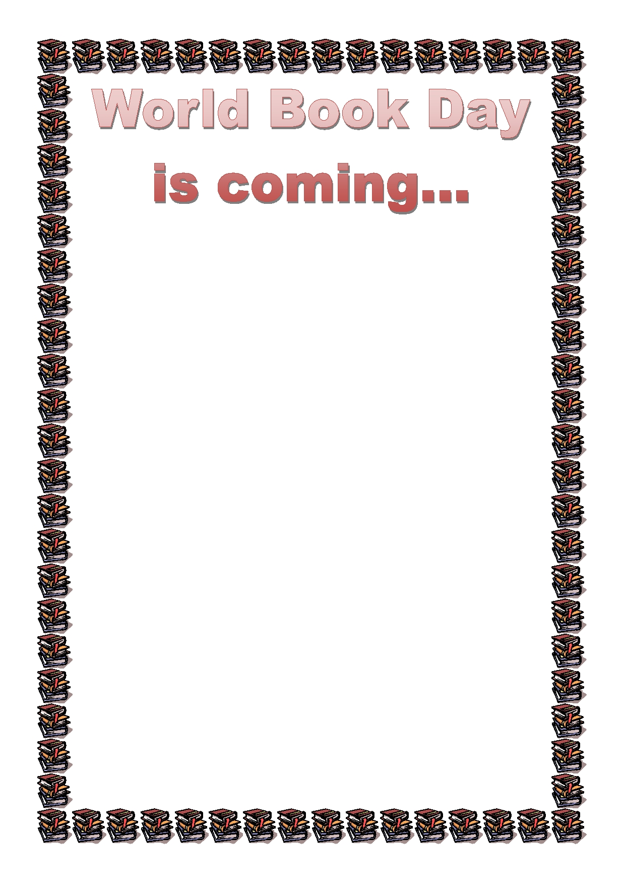
Dear parents and friends,
On Thursday 1st March 2018, we will be celebrating
World Book Day. All children are invited to come to school dressed in their pyjamas with their favourite
teddy or as their favourite book character, ready for a bedtime story at the end of the day.
Children can also bring their favourite books to share.
Throughout the day children will be invited to listen to stories and take part in activities to develop their love of reading. They will be incorporating art and design in- to their understanding of their favourite stories.

What is World Book Day?
World Book day is a celebration! It's a celebration of
authors, illustrators, books and (most importantly) it's a
celebration of reading! In fact, it's the biggest celebra-
tion of its kind, marked in over 100 countries all over the world. The main aim of World Book Day is to en-
courage children to
explore the pleasures of books and reading by provid-
ing them with the
opportunity to have a book of their own.

Miss Brown English Lead

Dear parents and friends,
On Thursday 1st March 2018, we will be celebrating
World Book Day. All children are invited to come to school dressed in their pyjamas with their favourite
teddy or as their favourite book character, ready for a bedtime story at the end of the day.
Children can also bring their favourite books to share.
Throughout the day children will be invited to listen to stories and take part in activities to develop their love of reading. They will be incorporating art and design in- to their understanding of their favourite stories.

What is World Book Day?
World Book day is a celebration! It's a celebration of
authors, illustrators, books and (most importantly) it's a
celebration of reading! In fact, it's the biggest celebra-
tion of its kind, marked in over 100 countries all over the world. The main aim of World Book Day is to en-
courage children to
explore the pleasures of books and reading by provid-
ing them with the
opportunity to have a book of their own.

Miss Brown English Lead

