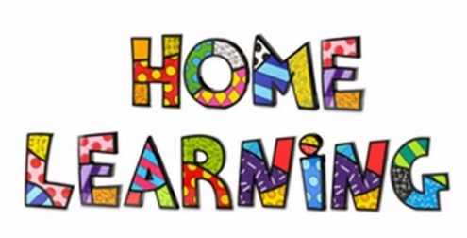

Useful Websites to support home learning
These websites have educational games, home learning ideas or even education videos. Please take a look and use these at home.

https://ttrockstars.com/ times tables practise (from this website you can also access Numbots which is another useful site – just click on the title for access)
https://www.twinkl.co.uk/ lots of learning resources
https://www.mymaths.co.uk/primary.html supports maths learning
https://www.purplemash.com/sch/grove-st1 Purple mash—logins in reading diaries
https://www.isleoftune.com/ computer and music programme—free
https://scratch.mit.edu/ programing and coding tool
http://www.magickeys.com/books/ online tool for books
http://www.mathsphere.co.uk/resources/ maths resources
https://www.bbc.co.uk/bitesize/levels/zbr9wmn different subjects covered—videos, resources
http://www.snappymaths.com/
https://whiterosemaths.com/
https://plprimarystars.com/
https://www.youtube.com/watch?v=d3LPrhI0v-w Joe Wick 5 minute moves—exercise to stay healthy
https://www.thepeshed.com/ PE activities
https://www.spellingshed.com/en-gb spelling activities
http://www.thegrid.org.uk/learning/history/ks1-2/resources/units/ lots of links to topics that are interesting to study
https://www.spellzone.com/ spelling activities
https://www.phonicsplay.co.uk/freeIndex.htm help with spellings
https://www.education.com/worksheets/phonological-awareness/ phonics resources
https://www.topmarks.co.uk/Interactive.aspx?cat=87 lots of interactive tasks and videos on a wide range of subjects.
https://www.teachyourmonstertoread.com/ free phonics and read which self assess and moves children on.
https://www.twinkl.co.uk/resources/keystage2-ks2 - free access for parents – useful resources
www.natgeokids.com National Geographic Kids
http://www.bbc.co.uk/history/forkids/ History for Kids
https://www.google.co.uk/intl/en_uk/earth/ Google Earth

